THE OUTPUT RESISTANCE OF A POWER SUPPLY

# Abstract

In this exercise, we measure and model the current and voltage of two circuit diagrams, first with a battery, and then later with a power supply. As the only difference between the diagrams is the placement of the ammeter and the voltmeter, we can with these two setups determine the resistance of the ammeter, the current through the voltmeter, and the internal resistance of the battery. All these three parameters are usually assumed to be negligible. We will use a linear function to model the relation between the total voltage and the total current through the circuit. To evaluate the quality of our models, we calculate and discuss the reduced Chi squared value of our model and data. This analysis was done in Python by use of the numpy, scipy and matplotlib modules.

# Introduction

In this exercise, we measure and model the current and voltage of two circuit diagrams, first with a battery and then later with a power supply, see OutputResist.pdf. The theoretically predicted relationship between the terminal voltage (V_1), the open circuit voltage (V_inf), the current passing between the nodes of the battery/power supply (I_2) and the output resistance of the power source (R_internal), is:

V_1 = V_inf – R_internal * I_2

This relationship is modelled by a linear relationship y = a*x+b.

Furthermore, we know that the terminal voltage V_PS = V_1, the voltage measured in the circuit configuration 1. The voltage difference over the resistor V_R = V_2, the voltage measured in the circuit configuration 2. Also, the potential difference over the ammeter V_A = V_PS – V_R.

By this notation, we also have the following relations:

I_PS = I_2, I_R = I_1, I_V = I_PS – I_R, and thus

I_V = I_2 - I_1.

Furthermore, by ohms law, we have

R_A = V_A / I_A = V_A_1 / I_A_1 = (V_PS – V_R)/I_1 = (V_1 – V_2)/ I_1.

Thus, we have the relations for the current through the voltmeter, I_V = I_2 – I_1, and the relation for what resistance the ammeter has: R_A = (V_1 – V_2)/ I_1.

In our experiment, V_1 and V_2 are our dependent variables, while R_internal, R_A, I_1, and I_2, are independent variables.

# Methods, Materials and Experimental Procedure

We successfully followed the procedures as described in the OutputResist.pdf document.

# Results

From our model of the total voltage and current, for the 6V battery, we found that:

V_inf = 6.31 V +- 0.1V

R_internal = 0.77 ohm +- 2.209 Ohm (using the standard deviation of the power supply internal resistance estimates as uncertainty).

chi2reduced = 0.00020972

Similarly, for our power supply with the 6V setting:

V_infty = 6.00 V +- 0.1V

R_internal = 48.37 ohm +- 2.209 Ohm

chi2reduced = 0.00006698

For the power supply with the 10V setting:

V_infty = 10.00 V +- 0.1V

R_internal = 51.73 ohm +- 2.209 Ohm

chi2reduced = 0.00000218

For the power supply with the 15V setting:

V_infty = 15.00 V +- 0.1V

R_internal = 45.84 ohm +- 2.209 Ohm

chi2reduced = 0.00002729

For the power supply with the 20V setting:

V_infty = 20.00 V +- 0.1V

R_internal = 46.99 ohm +- 2.209 Ohm

chi2reduced = 0.00000242

Therefore, the average internal resistance of the power supply with uncertainty, estimated from these measurements are:

R_internal_power_supply = 48.23 +- 1.1045 Ohm (uncertainty = 2.209/sqrt(N)).

We will associate a similar uncertainty to our estimate of the battery’s internal resistance, as that experiment were performed similarly to those with the power supply:

R_internal_battery = 0.77 +- 2.2 Ohm.

This will be our estimate of the internal resistance of the power supply and battery.

Furthermore, averaging and taking the standard deviation of each ammeter resistance estimate from the 6 resistors for the 4 different voltage settings of the power supply, we find that our estimate of the resistance of the ammeter is: 16.9 +- 7.18 Ohm

The voltage passing through the voltmeter varies for each voltage setting, but for instance, the current through the voltmeter is: -0.00012 Ampere when the total current through the circuit is 0.0059 Ampere, the terminal voltage is: 6 volts, and the resistor in the circuit is 100.0 kilo Ohm.

Run the python script in the appendix to get all the different currents through the voltmeter for each resistor and power supply setting.

Below in Figure 1-5, we see our data from the experiments plotted as points with corresponding error bars. Furthermore, we see the curve of our model fitted to the data, as described in the introduction.

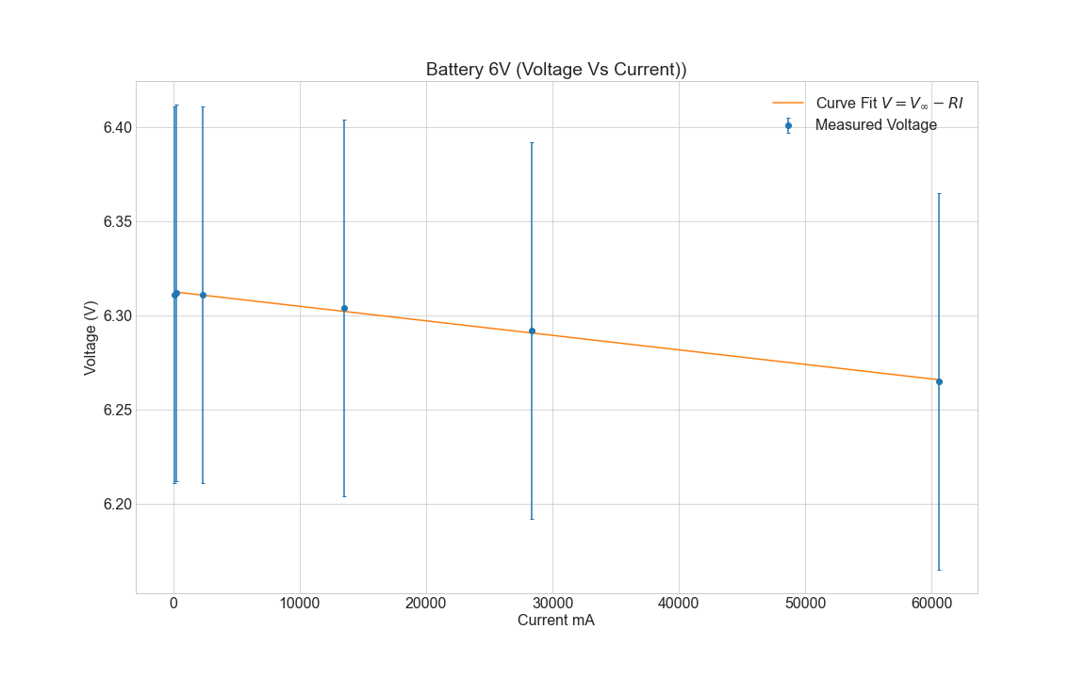

*Figure 1: Total Current vs. Total Voltage for the 6V Battery*

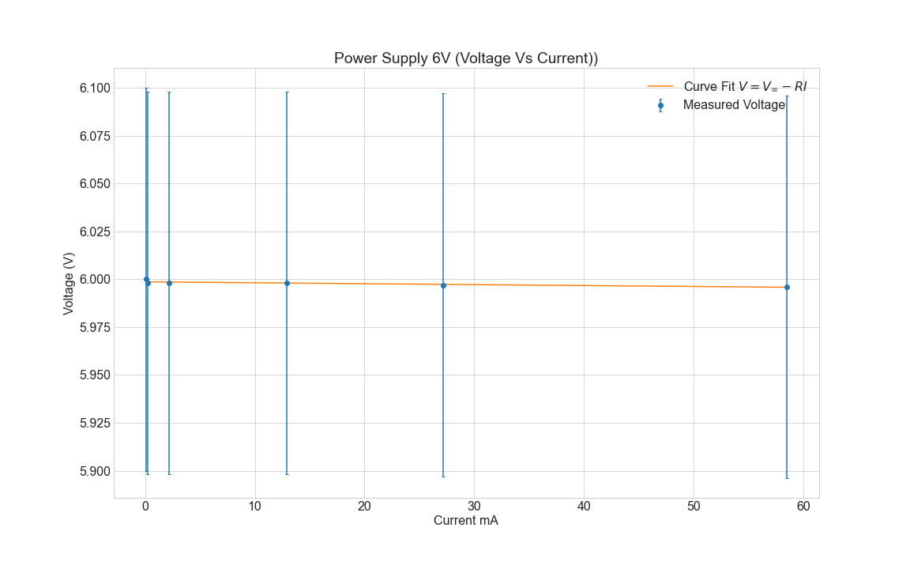

*Figure 2: Total Current vs. Total Voltage for the 6V Power Supply*

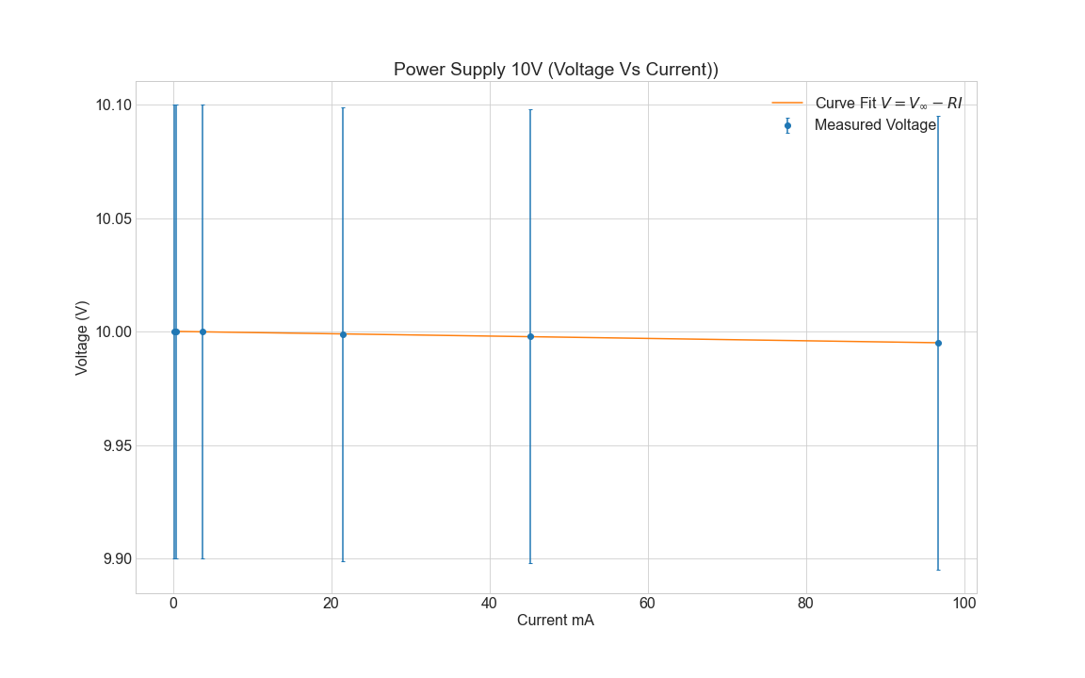

*Figure 3: Total Current vs. Total Voltage for the 10V Power Supply*

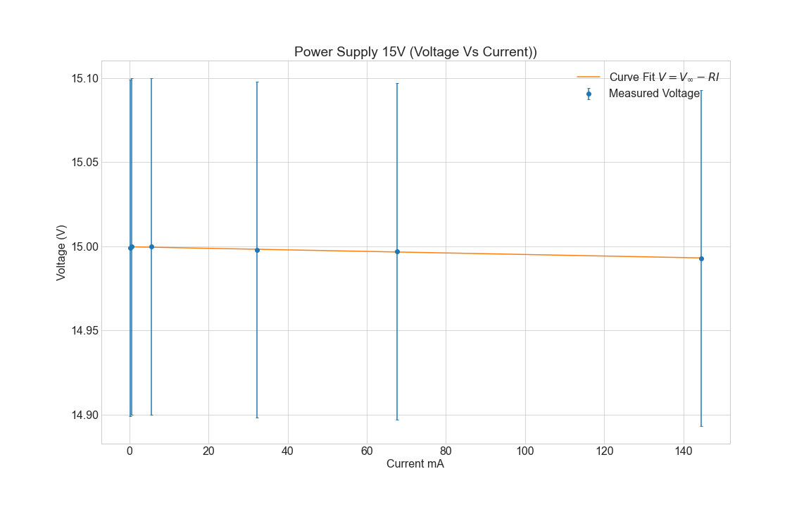

*Figure 4: Total Current vs. Total Voltage for the 15V Power Supply*

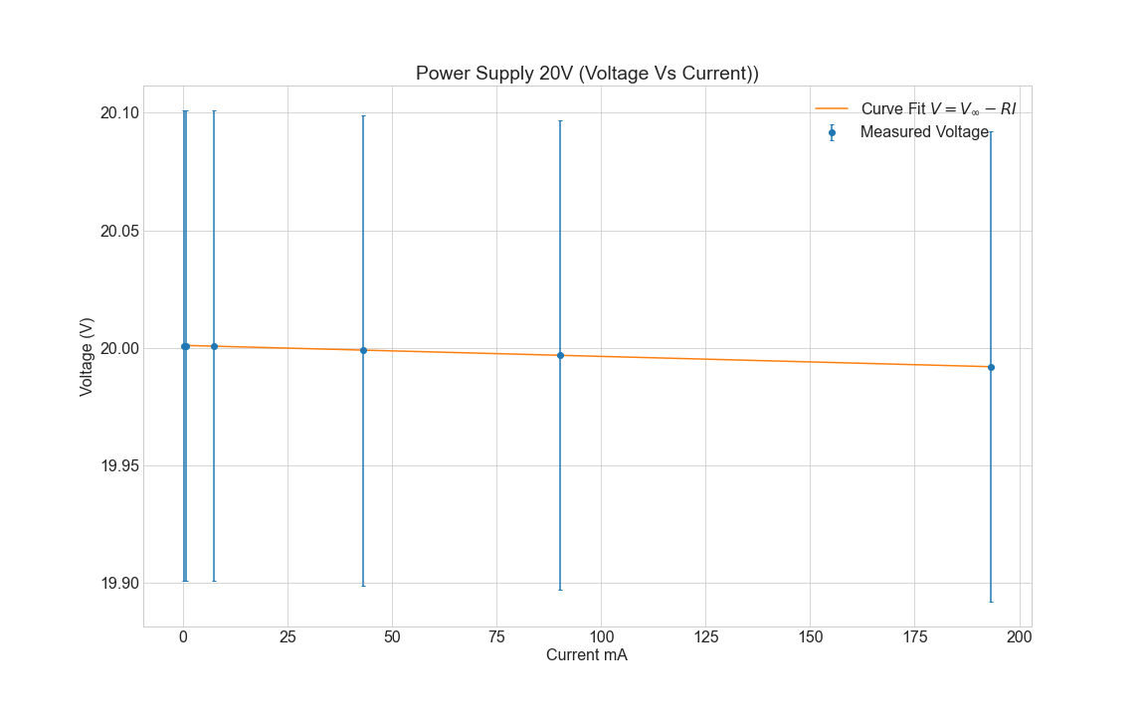

*Figure 5: Total Current vs. Total Voltage for the 20V Power Supply*

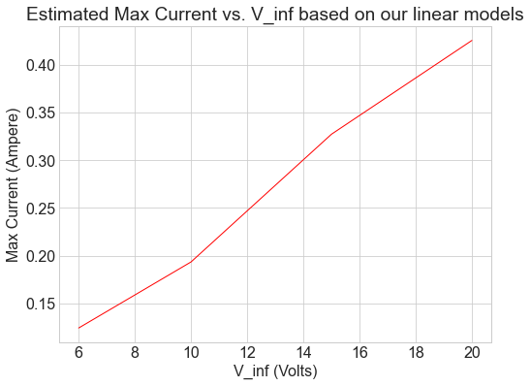

*Figure 6: Estimated Max Current vs. V_inf Based on our Linear Models*

# Discussion

The reduced Chi squared values we found were very low. This means that our models fit our data very well. However, our reduced Chi squared values should ideally be equal to one for most experiments. That we have extremely low reduced Chi squared values implies that we do not have enough data. It means that we are in risk of overfitting our models to our data. However, this exercise asked for data from four resistors, while we used six. Thus, in our case, the small reduced chi squared values is a good sign, as it means that we have good linear data for which our model fits nicely. Furthermore, both models are well within the uncertainties of our measurements, see Figure 1 to 5 in the Results section.

As we can see from the current passing through the voltmeter, it is very small in comparison to the measured total current in the circuit, see the results section. This is a good sign, as ideally no current should pass through the voltmeter. The current is also negative, which is not a surprising result. Within the voltmeter there is a battery made for compensating for the drop in voltage caused by the presence of the voltmeter in the circuit. If this battery overcompensates for the voltage drop, current will flow in the opposite direction of normal flow (according to the power supply). This is what we observe.

Furthermore, the estimated resistance of the ammeter is small in comparison to the resistance of the different resistors for which we used in our circuits. Whether the resistance is negligible depends on the resistance of the resistor in the circuit, which in our experiments varied in size from 100Ohm to 100k Ohm.

The estimated internal resistance of the power supply was large and significant in comparison to the smaller resistors we used, though negligible for the larger resistors we used. We got satisfactory small uncertainties in our estimate of the internal resistance for the power supply. However, for the battery, the estimated internal resistance was indeed very small and negligible in comparison to all the resistors in our experiments.

Now for answering the specific questions in the lab manual:

Question 1:

There is no better circuit diagram of the two. In the first one, the voltmeter measures the total potential difference in the circuit over the battery, while the ammeter measures the current flowing through the resistor. In the second diagram, the voltmeter measures the voltage difference over the resistor, while the ammeter measures the total current flowing in the circuit, from one node to the other of the battery. Together, measurements of current and voltage for each of the diagrams, determine what current run through the resistor, what current run through the voltmeter, and what current runs from the cathode to the anode of the battery. Likewise, we are able to determine the potential difference over the battery, over the resistor, and over the ammeter. With ideal multimeters, there should however be no difference between the two.

Question 2:

We chose to measure current and voltage for the two diagrams with as many different resistors as possible, of those we had easily available, to increase our reduced chi squared value for our model. Thus, we used all six resistors on the circuit board. Furthermore, statistically by the central limit theorem, a higher number of measurements results in a lower uncertainty in our estimates for the internal resistances of the battery, power supply and ammeter along with the current through the voltmeter, when averaging.

Question 3:

See introduction. Furthermore, though I_V varies for each resistor and power supply voltage, by averaging the estimated R_A for the data associated with each resistor and power supply/battery voltage, we can get a better estimate of R_A, see the results section.

As we mentioned previously in the discussion, the resistance of the ammeter is small and negative. This is due to its large resistance and the overcompensation for voltage by the small internal battery of the voltmeter.

Question 4:

See plots in the results section to see the estimated relationship between the current and voltage of the circuit according to our data. For the range of resistors for which we utilized in our experiments with the power supply, the current and voltage followed a linear relationship. However, according to the theory, for higher currents, we should see a non-linear relationship. However, we never reached currents which formed non-linear relationships with the voltage.

However, the maximum current, is the current

However, the maximum current is the current between the terminals of the power supply when V_inf is approaching zero. We can estimate this value from our linear relations, though this will be a poor fit with the theoretically predicted maximum current, if the voltage current-relationship is non-linear at higher currents:

At I_max, V=0, thus according to the equation from the introduction, V = V_inf – R_internal * I

So, I_max = V_inf/R_internal.

We then get an increasing relationship between V_inf and I_max, see Figure 6 in the results section.

# Conclusion

In this exercise, we measure and model the current and voltage of two circuit diagrams, first with a battery, and then later with a power supply. We successfully followed the instructions for the experiments written in the OutputResist.pdf lab manual. We have plotted our data with error bars, along with our corresponding linear models. Furthermore, we have calculated and discussed the reduced Chi squared values of the models, and estimated the internal resistance of the power supply, the battery, the ammeter, and the current flowing through the voltmeter. Finally, we have answered the questions of the lab manual.

# References

OutputResist.pdf

# Appendices

The codes and data we wrote for this experiment is shown below in Code 1, Code 2, and Data 1-10. Code 1 estimates the resistance with uncertainty of the ammeter. Code 2 fits and plot our linear models to the data. Code 2 also estimates the internal resistances of the battery or the power supply (depending on which data files it gathers data from), the V_inf and the reduced chi squared models of our models. Finally, Code 2 calculates and plots the relationship between the max current and the open-circuit voltage, V_inf